Hi,

Here's some things to get you started.

Website Details

Background Colour:  #E6E6FA Hex Color

Font: For now, Montserrat: <https://fonts.google.com/specimen/Montserrat?selection.family=Montserrat>

Favicon:  Yin Yang symbol (attached as SVG)

Homepage Image:  Rock Salt Lamp (attached as JPEG)

Useful Links

Tiny Tarot website that we'll model off of:

<http://chelseastearns.com/tinytarot/>

The CSS image rotate code for cards:

<https://www.w3schools.com/cssref/css3_pr_transform.asp>

The CSS image colour change for rock salt lamp 'glow' effect:

<https://www.w3schools.com/css/css3_animations.asp>

A link to create a Jot Form which I would like to create a 'Contact' box on the 'Contact' page:

<https://www.jotform.com/?utm_source=formfooter&utm_medium=banner&utm_term=71248834571259&utm_content=jotform_button&utm_campaign=powered_by_jotform_signup_hp>

Final Comments/Attachments

I've attached the tarot cards as a zip. There are 22 plus the back of card image making 23. Some need cropped again slightly so I will re-send them once they're fixed.

I have attached a word document for how it should look as drawn out called 'Website Pages Illustrated'.

I will be working on finalizing the phrases for each card this week.

With love,

Heather

POET TAROT READER

About

Contact

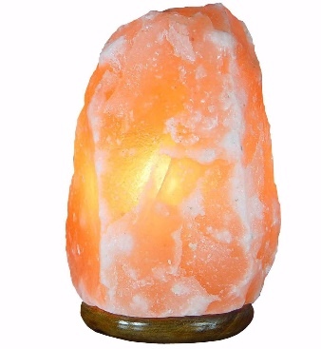

Enter



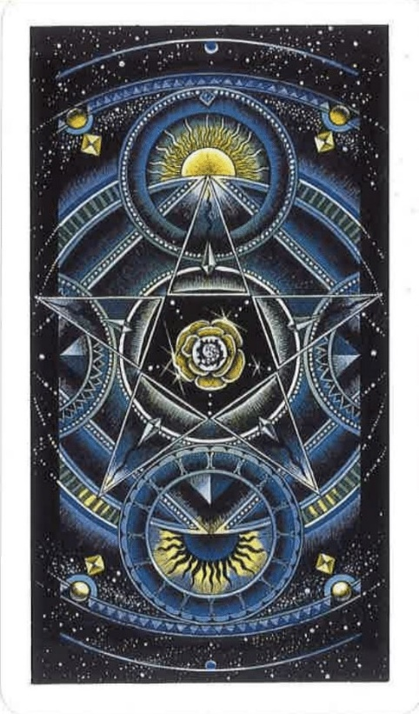

Would you like for the reading to contain reversed cards?

Yes/No



Think about what you would like to know from the reading. You can interpret lines 1, 2, and 3 as:

1. Past / Present / Future

2. What helps you / What hinders you / What are your realized and unrealized potentials

3. Current situation / Challenges / Guidance

4. What you think / What you Feel / What You Do

5. You / Your Partner / Your relationship

6. Strengths / Weaknesses / Advice

7. Mind / Body / Spirit

Ok

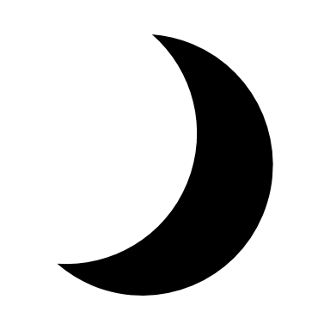

Shuffling



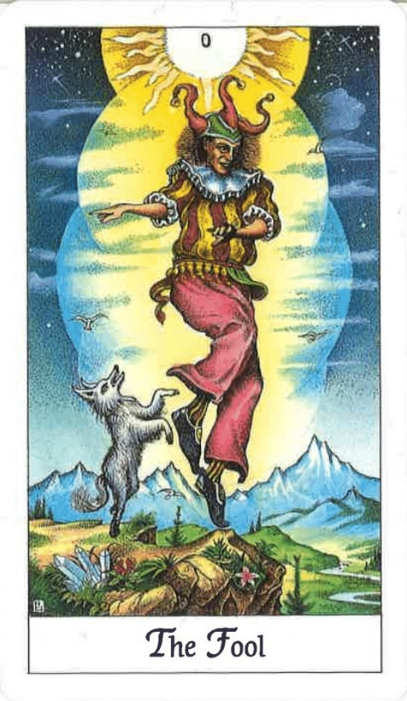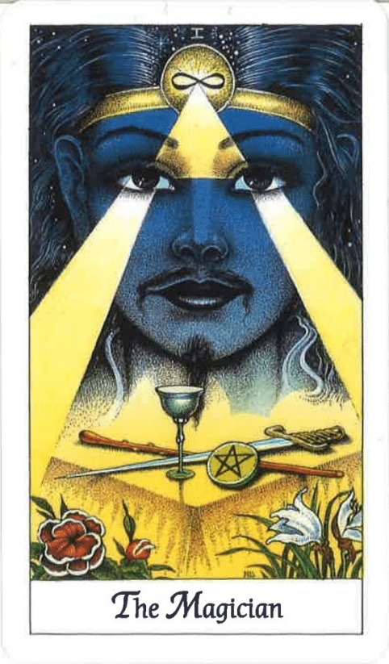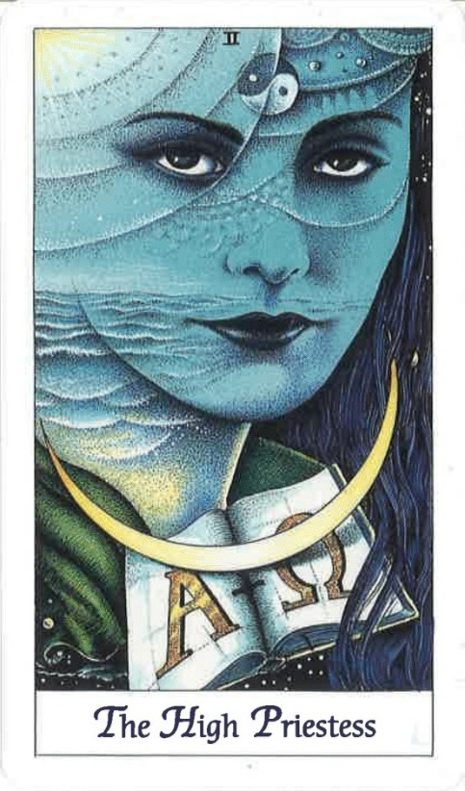

Your Poem:

At the edge, surprise is a prism

Seeing the red in white, atoms in orbit

What tides turn the moon inside?

(Share button Twitter/Facebook)

Again

> (Would go back to ‘Shuffling’ Page 4)

ABOUT

Poet Tarot Reader produces poems as tarot readings.

When a visitor shuffles the cards, a calculation occurs to determine which three cards will present for them from the Major Arcana, including whether any cards are reversed.

Poetic lines that offer exposition on each card appear.

These accumulate to form an individual 3-line poem.

The generated poem is offered to the visitor to interpret, weaving meaning across lines.

Poet Tarot Reader realises a spiritual alchemy with poetic lines as tarot cards and poems as tarot card readings.

Poet Tarot Reader uses Cosmic Tarot cards by Norbert Lösche which you can purchase [here.](http://www.shamanscrystal.co.uk/product/14/cosmic-tarot-cards-deck/?utm_source=google&utm_medium=cpc&utm_campaign=product-extensions&gclid=Cj0KCQjwzIzWBRDnARIsAAkc8hEcJ99GQhn3_VvqU67Zy6oinabEDbs6gfh5cTRz-fn5zC_NEbnPm2gaAhjtEALw_wcB)

CONTACT

Poet Tarot Reader was created by Heather O’Donnell and Conor Mckeown.

Heather O’Donnell is a poet and Conor Mckeown is a game developer.

